**Resizing Disk**

These are the steps for disk resizing.

* **fdisk –l  (To List all disks)**
* **apt-get update**
* **apt-get install cloud-initramfs-growroot**
* **growpart /dev/sda 1**



* **resize2fs /dev/sda1**

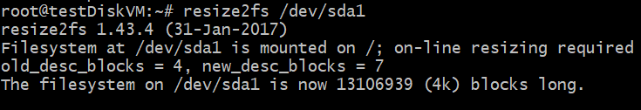

* **df –h**

